Lab Report #3

Introduction to Power Supplies

Feher Dabbagh

Physics 385L

Abstract:

Measuring AC voltages while using a transformer as a power supply in various circuits. Some of the circuits used were half and full wave rectifiers as well as bridge rectifiers. A combination of diodes, capacitors and resistors was used to in various setups for each respective circuit.

Background:

How to properly use an Oscilloscope, the proper handling of a transformer,

Procedure: The procedure followed is outlined on the attached lab document provided in class.

Presentation:

3-1 Transformer Output Voltage Measurements

By adjusting the how the transformer is grounded in a circuit influences the output voltage. By grounding the entire width of the transformer the RMS of the voltage drops from 39.20 V for when the center tap is grounded to 14.19 V for the entire transformer is grounded.

The phase relation between the Secondary and the Winding are same the output voltage however changes depending on how much of the transformer is connected to the circuit.

3-2 Diodes

|  |  |  |
| --- | --- | --- |
|  | RMS | Peak to Peak |
| Channel 1 | 1.549 V | 4.40 V |
| Channel 2 | 457.3 mV | 1.340 V |

Resistor: 105.2 Ω v = 60 Hz

3-3 Half-Wave Rectified Power Supply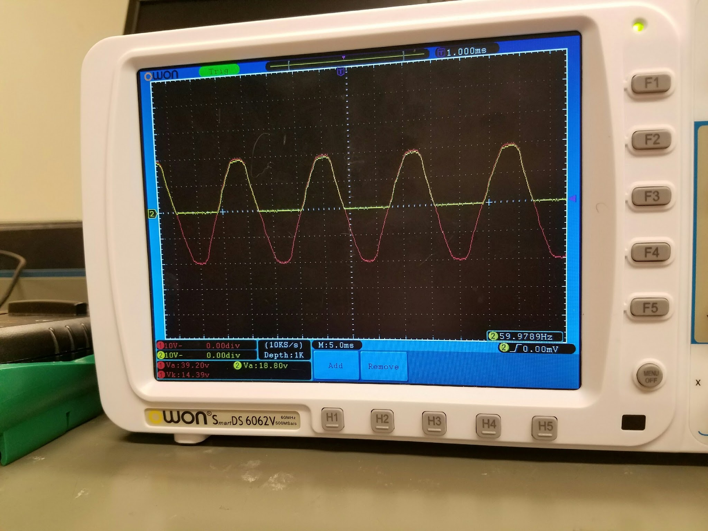

To the left is the graph generated by the oscilloscope when the diode’s cathode and anode are properly placed. Reversing the anode and cathode ends of the diode flips the signal from channel 2 (Yellow line) as shown in the second image.

In this image the diode is reversed causing the signal being read by Channel 2 to also be reversed. 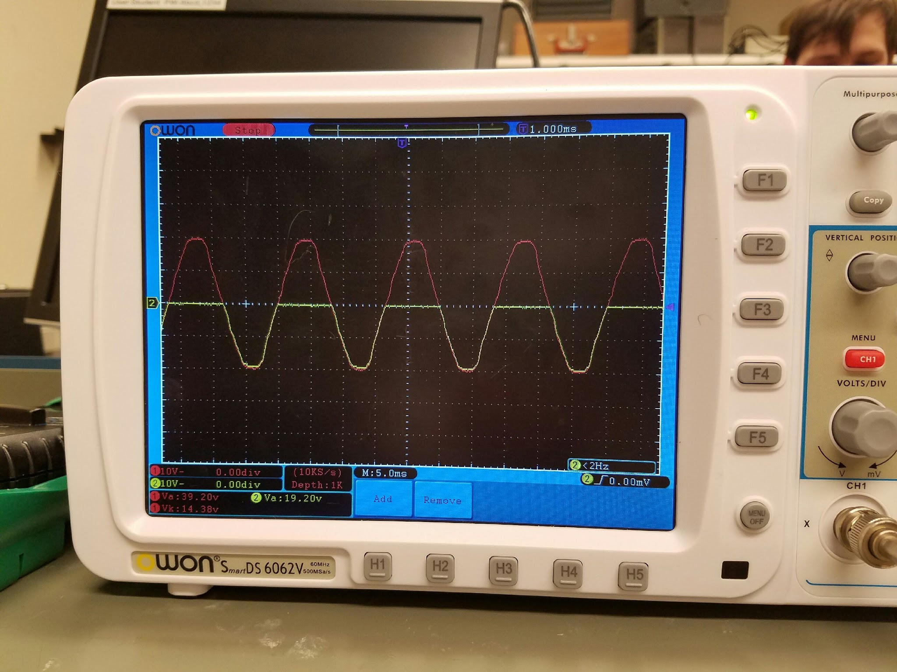

3-4 Full-Wave Rectified

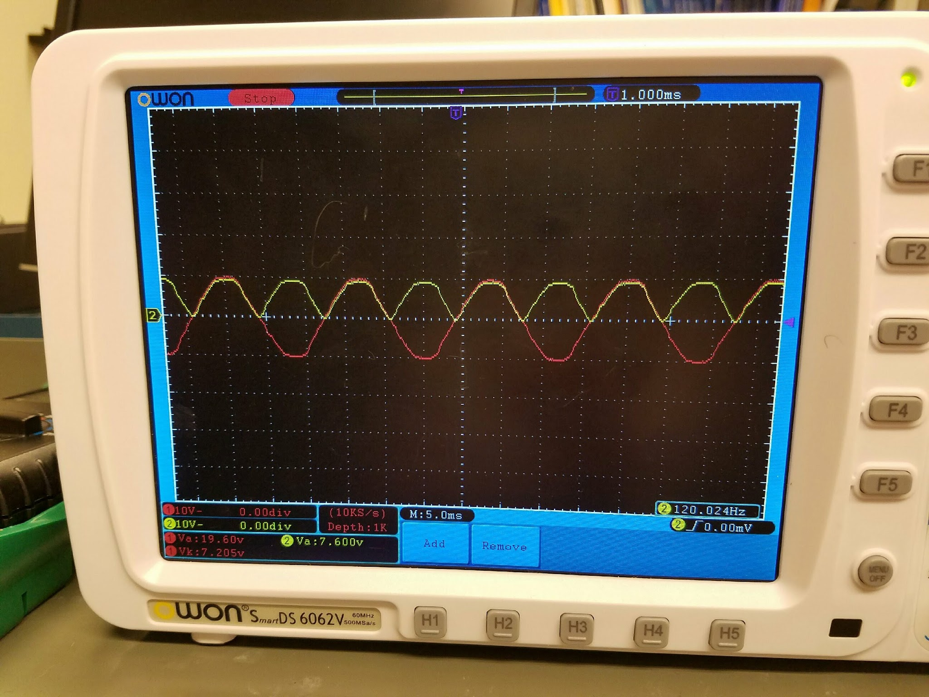

The image to the right shows the signal from scope 1 and 2 of the oscilloscope when connected to a full wave rectifier.

3-5 Bridge Rectifier

|  |  |  |
| --- | --- | --- |
|  | Input Voltage | Output Voltage |
| RMS | 14.19 V | 9.65 V |
| Peak to Peak | 39.20 V | 20.00 V |
| Amplitude | 38.40 V | 19.60 V |

3-6 Filter Capacitors

The following series of images show readings from the oscilloscope with various capacitor-resistor pairs.

|  |  |
| --- | --- |
| Resistor: 200 Ω Capacitor: 10 μF  IMG_20170227_113456.jpg  Input RMS: 7.996 V  Output RMS: 9.415 V | Resistor: 1kΩ Capacitor: 10 μF  IMG_20170227_113730.jpg  Input RMS: 7.943 V  Output RMS: 185.5 mV |
| Resistor: 200 Ω Capacitor: 100 μF  IMG_20170227_113546.jpg  Input RMS: 7.911 V  Output RMS: 15.58 V | Resistor: 1 kΩ Capacitor: 100 μF  IMG_20170227_113809.jpg  Input RMS: 7.867 V  Output RMS: 7.545 V |
| Resistor: 200 Ω Capacitor: 1000 μF  IMG_20170227_113606.jpg  Input RMS: 7.792 V  Output RMS: 15.13 V | Resistor: 1 kΩ Capacitor: 1000 μF  IMG_20170227_113824.jpg  Input RMS: 7.784 V  Output RMS: 11.30 V |

3-7 Voltage Regulators

Input RMS: 6.70 V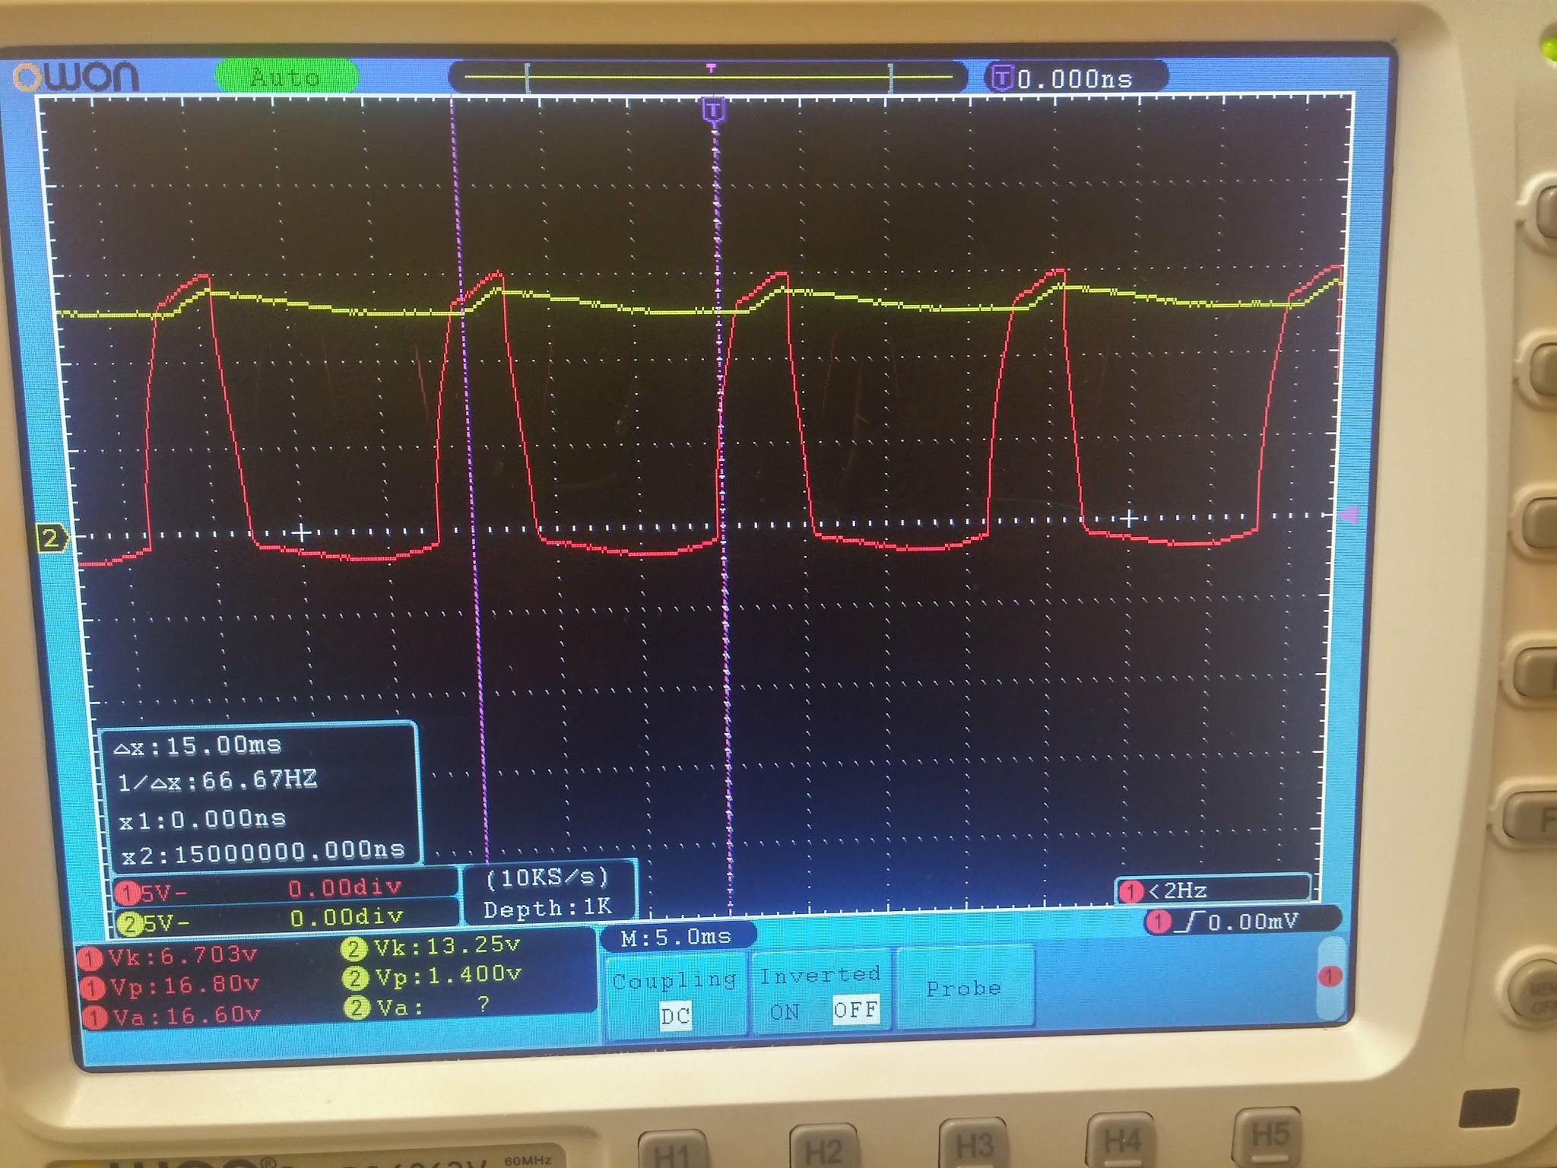

Output RMS: 13.25 V

Capacitor 1000 μF

Resistor: 1 kΩ

This image shows the reading from an oscilloscope connected to a Voltage Regulator Circuit.

Discussion:

3-1 Transformer Output Voltage Measurements: Due to the design of transformers wherein they have three wires soldered to the secondary, two on each end and one in the middle of the secondary. Where attaches the ground to the secondary has a significant influence on the output voltage of the transformer. Grounding the entire length of the transformer’s secondary generates a voltage that is less than half that when the transformer is grounded at the center tap of the secondary. This increase in voltage between the center tap and entire secondary comes at the cost of a decrease in current. However there is no change in the phase relationships between the two points, only the magnitude of the output voltage is changing.

3-2 Diodes: A diode is most easily distinguished by the circular band around one end of the device. The end most close to the band is the cathode and this makes the opposite end the anode. The image below shows an example of this.

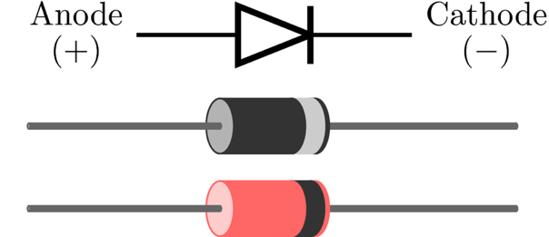

3-3 Half-wave rectified power supply: The diode in this circuit as shown in the 3-3 image above removes the bottom half of the wave form. This is the yellow line in the image. Reversing the orientation of the diode in the circuit reverses the effect it has on the current. As shown again by the yellow line the second image of the 3-3 section above. The diode effectively cuts the output voltage of the circuit in half.

3-4 Full-wave rectifier: In this circuit the resistor is made to be in parallel with the diode and a second diode is added to the circuit. Also of note is the second diodes orientation, tracing the circuit provided in the lab procedures the cathode ends of each diode are facing each other. The voltage is again reduced because of the diodes because of the second diode and the resistor being in parallel this further reduces the voltage when compared to previous section. Here the voltage never drops or stays at zero as it did in 3-3 but rather is a squished and always positive waveform. While in 3-3 the waveform is reduced to zero while the input voltage is below zero.

3-5 Bridge Rectifier: The voltage readings for the bridge rectifier circuit were similar to those recorded in the half-wave rectifier and larger than those of the full-wave rectifier. The inclusion and orientation of the additional diodes played a significant role in these results.

3-6 Filter Capacitor: By pairing various resistors and capacitors as outlined in the lab procedure we were able to measure the AC Ripple generated by the circuit. Comparing the voltages measured by the oscilloscope the most prominent ripple was found with the pairing of a 200 Ω resistor and a Capacitor of 1000 μF.

3-7 Voltage Regulator: The ripple that originates from the output of the regulator is because the regulator is designed to help maintain a near constant voltage within a circuit. In this case it is ensuring a constant voltage between the capacitor and resistor which are in parallel and connected at the In and Out portions of the regulator respectively.

Conclusion:

In conclusion transformers are alternating current providing power sources. The amount of current that a circuit pulls from a transformer depends on how much a transformer’s secondary is grounded. Furthermore combining an alternating current with diodes allows the circuit to partially mimic a direct current at least partially. Taking this a step further by combining 4 diodes, a resistor and capacitor pair, and finally a voltage regulator a circuit can almost directly mimic a direct current.